

**INSERT DOCTOR NAME**

123 Any Street, New York, USA

123-678-XXXX

Doctor Qualifications

Clinic Address

To Whom It May Concern:

Please Excuse: YOUR NAME

From:

□ Work

☑ School

□ Other:

Due To:

☑ Injury

□ Illness

□ Others:

For the following dates: 11/12/2024 to 11/14/2024

Doctor’s Comments: Acid Reflex

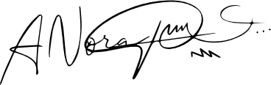

Medical License Number: _________________

March 20，2025