

**INSERT DOCTOR NAME**

123 Any Street, New York, USA

123-678-XXXX

Doctor Qualifications

Clinic Address

TO WHOM IT MAY CONCERN

Please excuse _________________ from work __/__/____ until __/__/____. After a thorough examination, I have diagnosed him/her with __________________________, and he/she requires rest to facilitate recovery. Based on his/her medical condition, I recommend that he/she be permitted to work remotely instead of performing onsite duties. During this period, I advise that the workload be limited to allow for adequate rest and healing.

This balanced approach will effectively support his/her recovery process while enabling him/her to continue fulfilling professional responsibilities without compromising health or the quality of work.

Sincerely

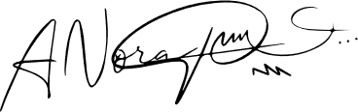

Medical License Number: _________________

March 20，2025